Frontend:

Admin Dashboard (ReactJs):
-Option to add or remove locations and vehicles
-Option to manually plan route for vehicles
-Display past patrol records
-Option to generate daily or monthly report
-Display All the vehicles details (car plate, contact number, driver in charge, vehicle health status)
-Track the real-time location of each vehicle on Google Map
-Show overall estimated carbon emission (Compare plan? shortest distance vs best traffic?) (plot graph of past estimated carbon emission record for each vehicle?)

Mobile app for each duty phone on vehicle (Flutter) (Data will be pulled from Firestore):
-Each account is linked to one vehicle
-Function to contact command center (message or phone call)
-Function to submit pictures of the location.
-Function to submit incident report
-Function to view overall route plan and the next location to go to

https://www.figma.com/file/go1jtwWq9kIJKcSw7mdQ5d/Dynamic-Routing?node-id=0%3A1&t=s6oGIn8DInlhbJTe-1

Factors affect that the carbon footprint emission: mileage and the engine type

Backend:

Database (MySQL):
-key-value pairs
-Vehicle and location details
-Daily patrol plans
-Images sent by guards for each location
Admin: username, password
Security Guard: name String, id INT, availability boolean, Vehicle ID INT, on_duty Boolean, is_driver Boolean
Vehicle: id, Car Plate number, Driver in Charge, Maintenance Status, availability, Current Route, Current location, Next Location,
Location: id, Name, Image, Emergency_trigger, priority,

Web Server (Django):
-OOP for vehicle and location
-Algo for the shortest path (Dijkstra, Bellman-Ford, Floyd-Warshall)
-Calculation of carbon footprint emission

Class vehicle
Class location

def shortestRoute(location_list: List, priority_location:List, num_car: int, ) -> List:

Factors: amount of fuels used and

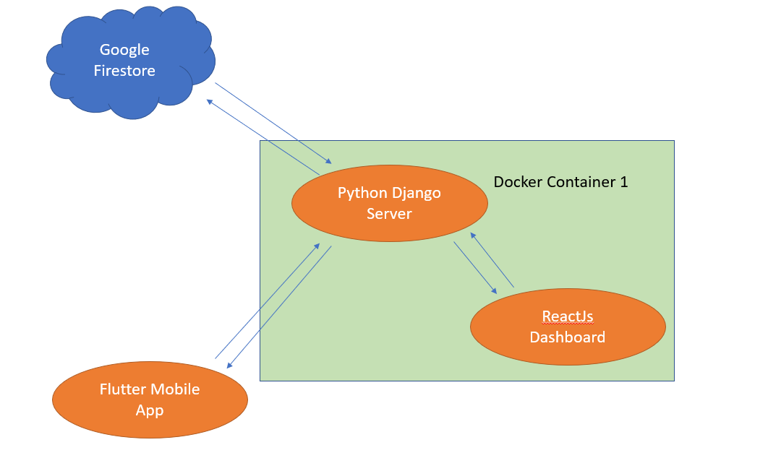

https://www.youtube.com/watch?v=Jx39roFmTNg
https://www.youtube.com/watch?v=JD-age0BPVo
https://www.youtube.com/watch?v=Geisa_ib5hs
https://www.quora.com/Algorithm-for-shortest-distance-across-multiple-locations
https://www.freecodecamp.org/news/dijkstras-shortest-path-algorithm-visual-introduction/#:~:text=Dijkstra's%20Algorithm%20finds%20the%20shortest,node%20and%20all%20other%20nodes
https://www.sciencedirect.com/science/article/abs/pii/S1361920921002923.
https://www.epa.gov/greenvehicles/greenhouse-gas-emissions-typical-passenger-vehicle
https://enveurope.springeropen.com/articles/10.1186/s12302-020-00407-5
https://connectedfleet.michelin.com/blog/calculate-co2-emissions
https://www.javatpoint.com/how-to-connect-mysql-to-django

